1. **INTRODUCTION**

**Overview**

* This tutorial will demonstrate how to use Android Compose to create a survey application that can accept text input and validate it. We will build an example survey application that allows users to enter their name, age, and gender. The application will then validate the user’s inputs.
* We will be using the Compose UI library to create the application. Compose is a modern UI toolkit for Android that makes it easy to create beautiful and interactive layouts. We will also be using the Compose Validation library to validate the user’s inputs.

Prerequisites

Before getting started, you will need the following:

• Android Studio

• Knowledge of the Kotlin programming language

• A basic understanding of Android Compose

**Purpose**

* The purpose of this demonstration is to show how to create a simple survey application using Android Compose. The application will use text input and validation to create a survey that stores the user's responses.

1. **PROBLEM DEFINITION & DESIGN THINKING**

* **Empathy Map**

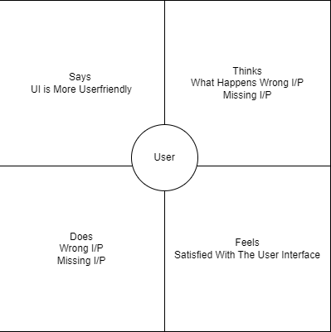

* **Ideation & Brainstorming Map**

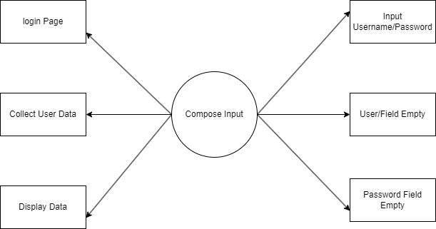

1. **DATABASE**

|  |  |
| --- | --- |
| **Object name** | **Fields in the Object** |
| Sign up | |  |  | | --- | --- | | Field label | Data type | | Username | String | | Password | String | | Email | String | |
| Log in | |  |  | | --- | --- | | Field label | Data type | | Username | String | | Password | String | |
| Survey Details | |  |  | | --- | --- | | Field label | Data type | | Name | String | | Age | String | | Mobile No | Numeric | | Gender | String | | Diabetics | String | |

* **The screenshots of your project activity along with the description.**

**Login Page Register Page**

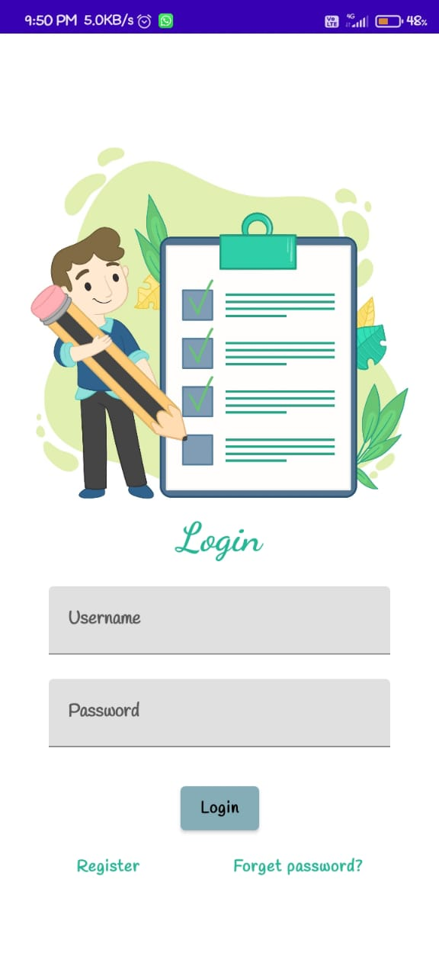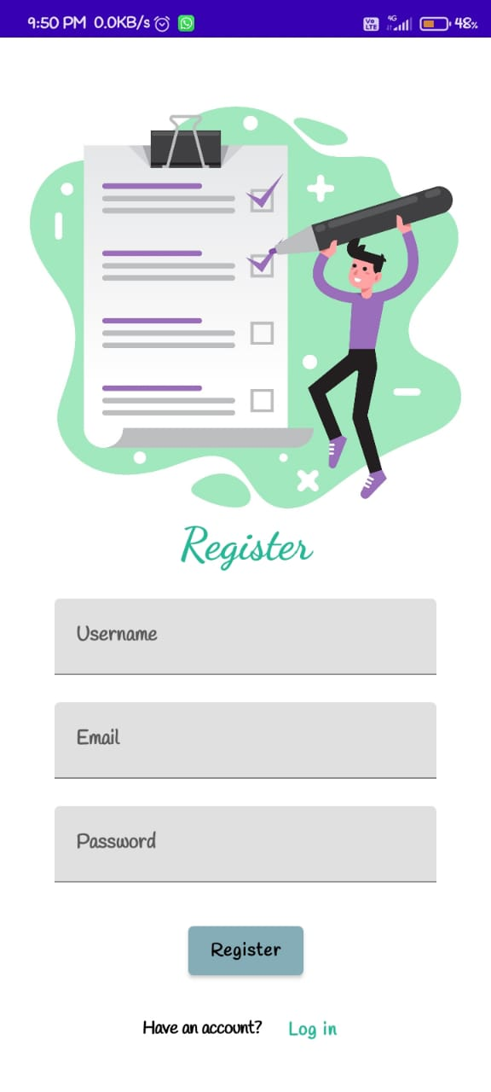

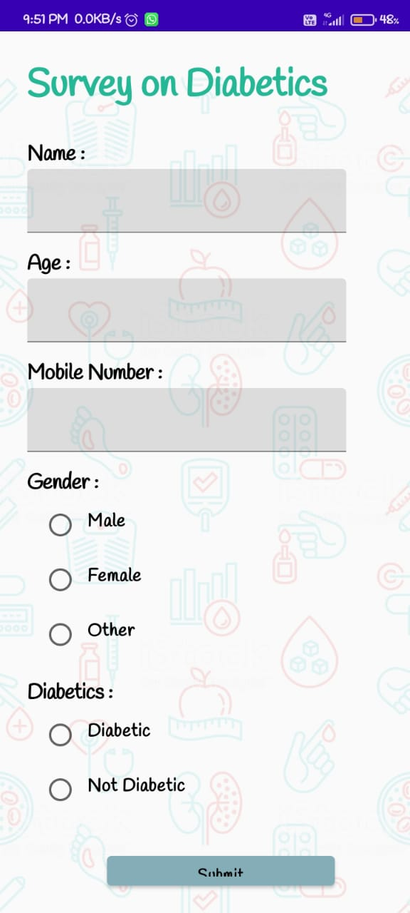 **Survey Details Page Survey Details Enter Page**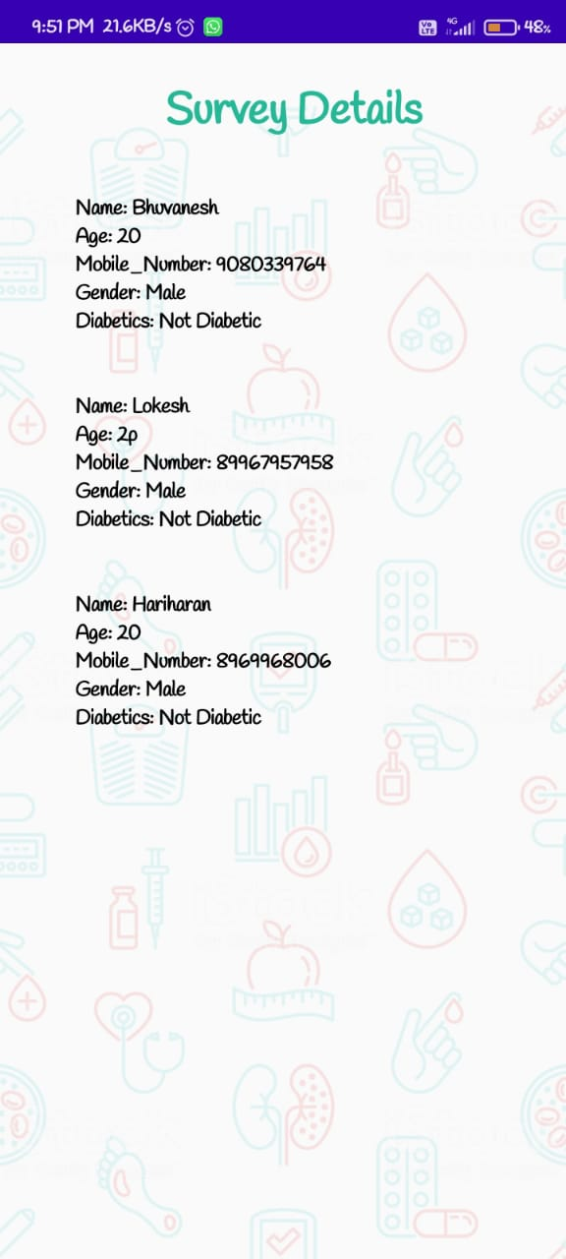

1. **GOOGLE DEVELOPER PROFILE PUBLIC URL**

Team Leader – <https://g.dev/Bhuvanesh43>

Team Member 1

<https://g.dev/Jeethesh35>

Team Member 2

<https://g.dev/Harikr>

Team Member 3

<https://g.dev/>Akshay1511

1. **ADVANTAGES & DISADVANTAGES**

**Advantages:**

* Android Compose helps to create a user-friendly and visually appealing interface. It helps to create a consistent look and feel for the application.
* Using Android Compose for text input and validation make it easy to create a smooth and efficient user experience. It allows for customization of the text input and validation process to meet the specific needs of the application.
* Android Compose also helps to reduce development time by providing easy-to-use tools that can quickly be implemented into an application. This allows developers to quickly create an application with minimal effort.
* Android Compose also provides a secure way to store and validate user input. This helps to ensure that the data collected is accurate and secure.
* Finally, Android Compose helps to simplify the process of developing a survey application. By providing a set of tools that can be quickly implemented, Android Compose helps to reduce the time and effort needed to create a survey application.

**Disadvantages**

* Android Compose is a relatively new technology and the documentation may not be as comprehensive as more established technologies.
* Android Compose is not yet compatible with older versions of Android and some features may not be available on certain devices.
* Debugging and testing can be challenging as the Android Compose library is still in its early stages.
* Android Compose is not yet as customizable as other technologies, so certain UI elements may not be able to be adjusted.
* Android Compose is not yet optimized for mobile devices, so performance may be an issue when running complex UI elements on mobile devices.

1. **APPLICATIONS**

* This demonstration will show how to create a survey application using Android Compose. The application will allow the user to input text and validate the input using a custom validation function. In this example, the user will be asked to enter their name, email address, and phone number. The application will then check to make sure that the information is valid before submitting the survey.
* First, we will create the layout for the application. This will include a Text-Field for the user to enter their name, an Email-Field for the user to enter their email address, and a Phone-Field for the user to enter their phone number. We will also add a Submit-Button which will be used to submit the survey.
* Next, we will create a function that will be used to validate the user's input. This function will check to make sure that the user has entered a valid name, email address, and phone number. If any of the inputs are invalid, the user will be notified and asked to re-enter the information.
* Finally, we will connect the Text-Field, Email-Field, Phone-Field, and Submit-Button to our validation function. When the user clicks the Submit-Button, the validation function will be called and the survey will only be submitted if the user.

1. **CONCLUSION**

* This project demonstrates how to create a user-friendly and secure text input and validation system using Android Compose. This project focused on creating a survey application that allows users to input text-based information and then validates the data collected. The application includes features such as input validation, error messages, and a confirmation page that summarizes the user's input. The validation process ensures that the user input is valid and that the data is secure. This project is an example of how Android Compose can be used to create an effective and secure text input and validation system.

1. **FUTURE SCOPE**

* This demo provides an example of how text input and validation can be implemented using Android Compose. The application is a simple survey application that allows the user to answer questions with text input.
* The application begins by displaying a welcome page that contains a brief introduction and instructions for the survey. The user is then taken to the survey page which contains a series of questions. Each question has a text field for the user to enter their answer.
* The text input is validated to ensure that the user has entered valid input. If the user enters an invalid answer, a validation error message is displayed. The user is then required to enter a valid answer before they can continue.
* Once the user has completed the survey, they are taken to a results page. This page displays the answers that the user has entered, as well as any validation errors.
* In the future, this demo could be extended to include additional question types such as multiple choice, checkboxes, and dropdowns. Additionally, the application could be enhanced with features such as multiple surveys, survey sharing, and survey analytics.